***Diagrams:***

1. Server Class Diagram
2. Component Diagram
3. Windows State machines
   1. Welcome Screen (general system SM)
   2. Login Screen
   3. Register Screen
   4. Edit Details Screen
   5. Edit Avatar Screen
   6. Search Room
   7. Create Room
   8. Game Room
   9. View Replay
4. Sequence Diagrams
   1. Search Games
   2. Join Existing Game
   3. Spectate Active Game
   4. Start Game and Deal Cards
   5. Leave Game
   6. Fold
   7. Check
   8. Bet

***Server Class Diagram:***

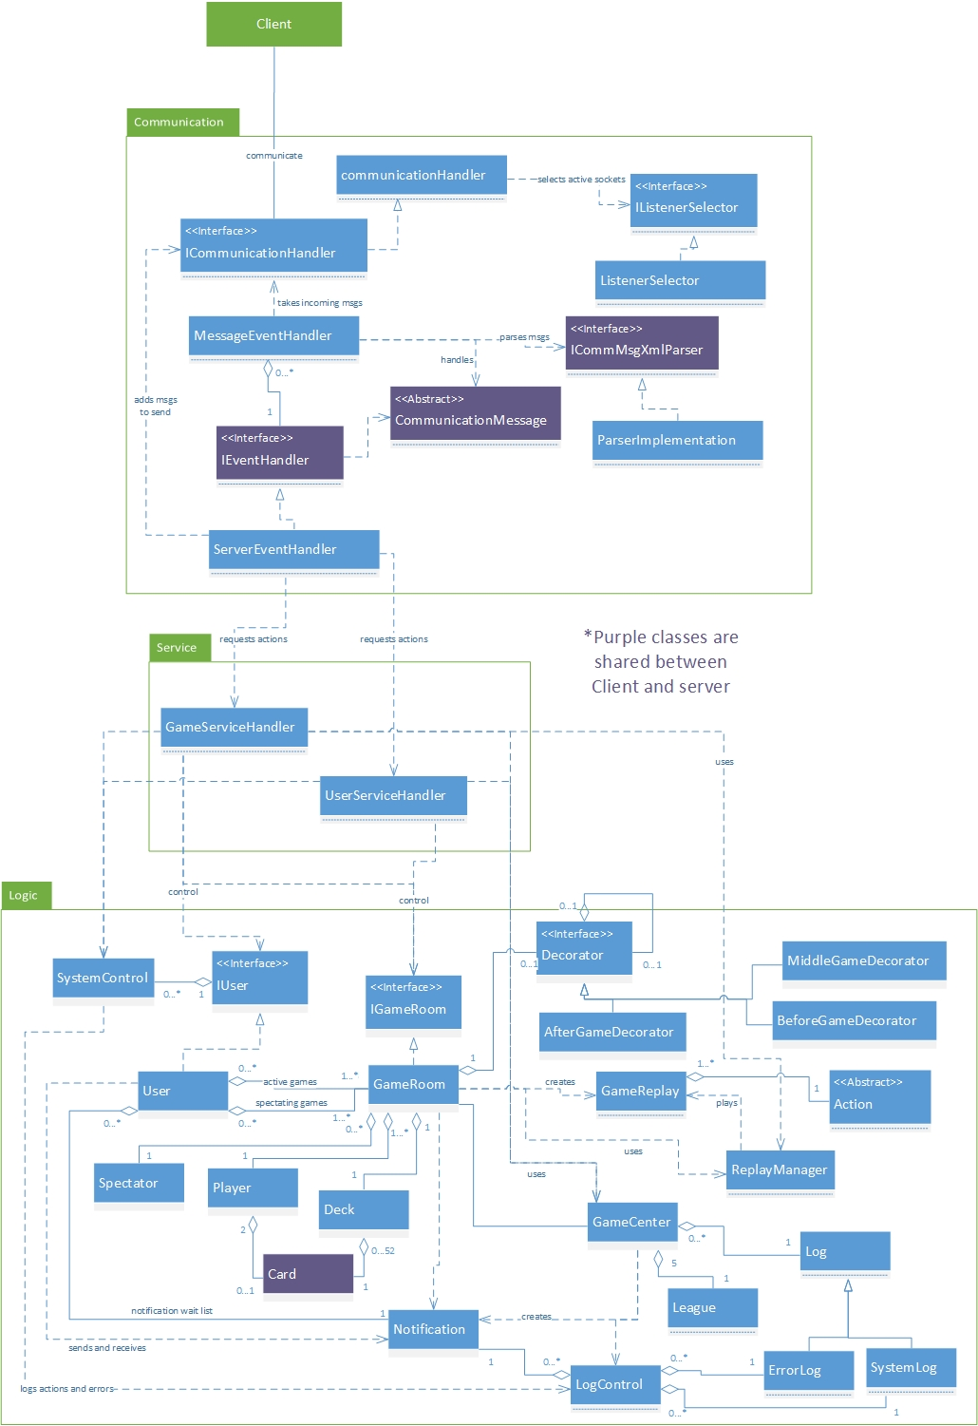

***Component Diagram:***

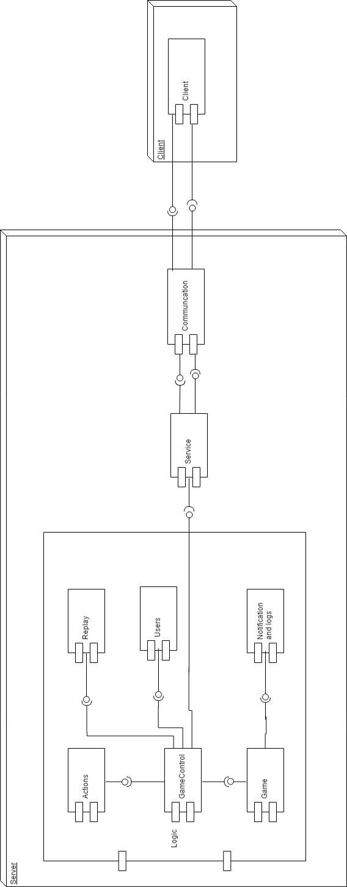

***Windows State Machines:***

Welcome Screen (general system SM):

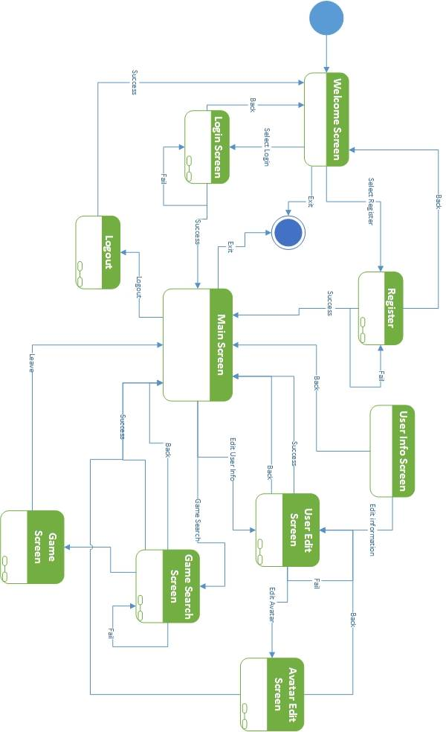

Login Screen:

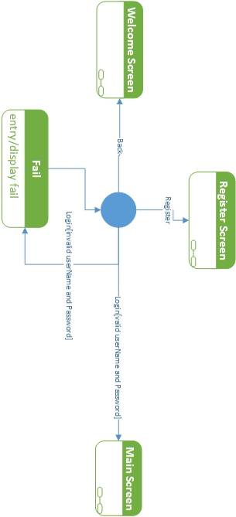

Register Screen:

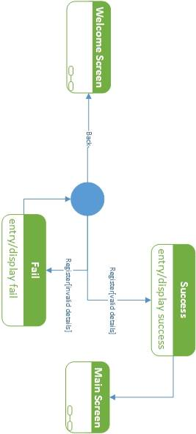

Edit Details Screen:

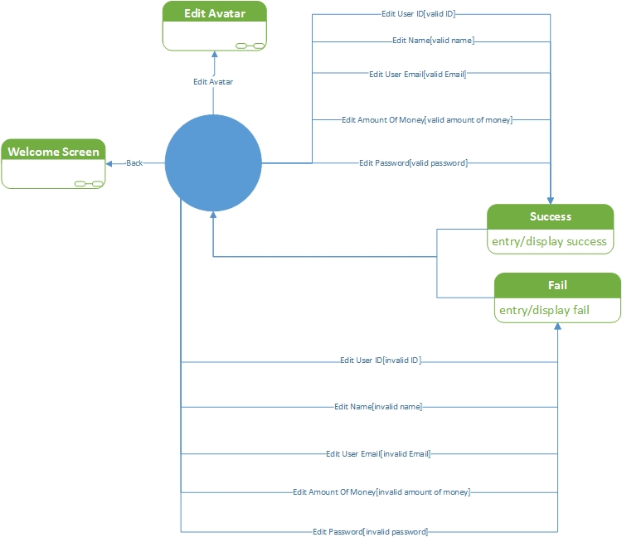

Edit Avatar Screen:

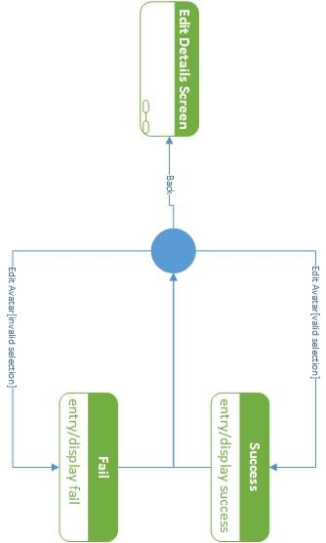

Search Game Screen:

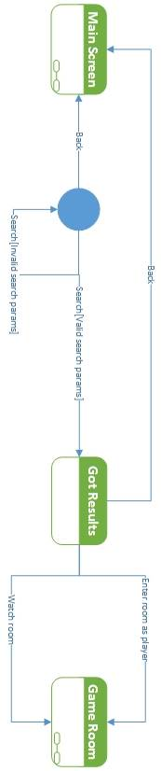

Create Room Screen:

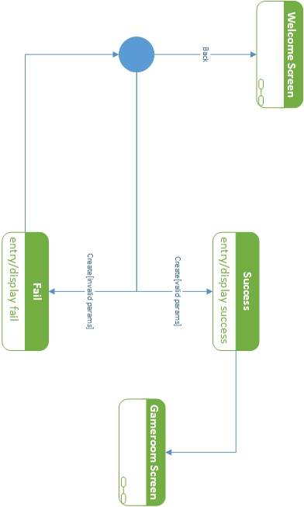

Game Room Screen:

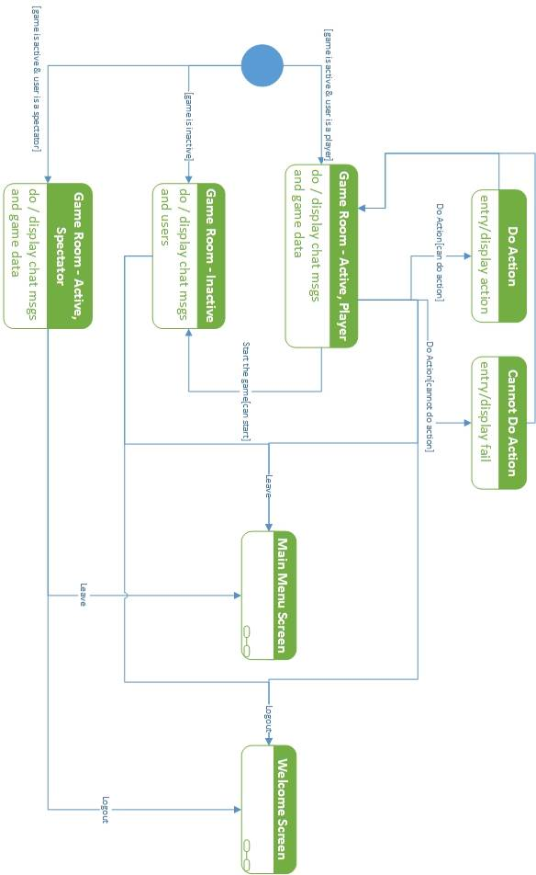

View Replay:



***Sequence Diagrams:***

Search Games:

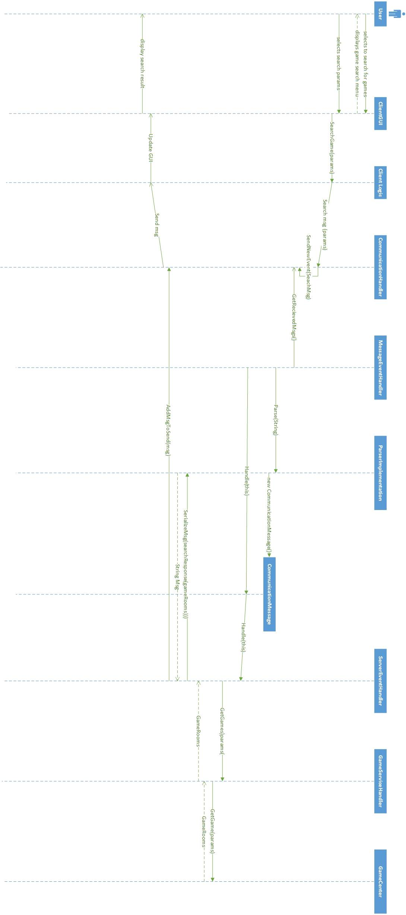

Join Game:

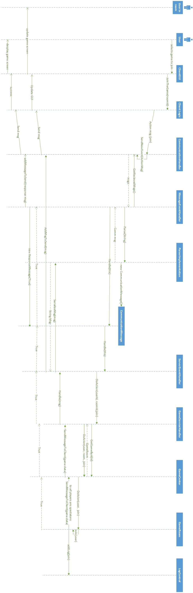

Spectate Existing Games:

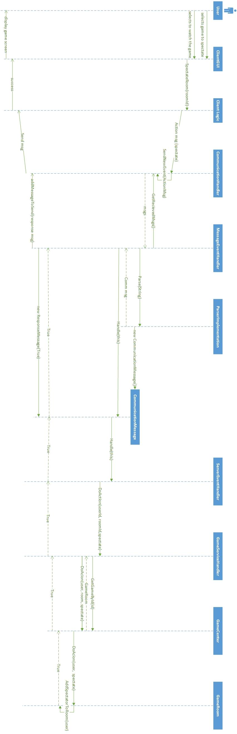

Start Game and Deal Cards:

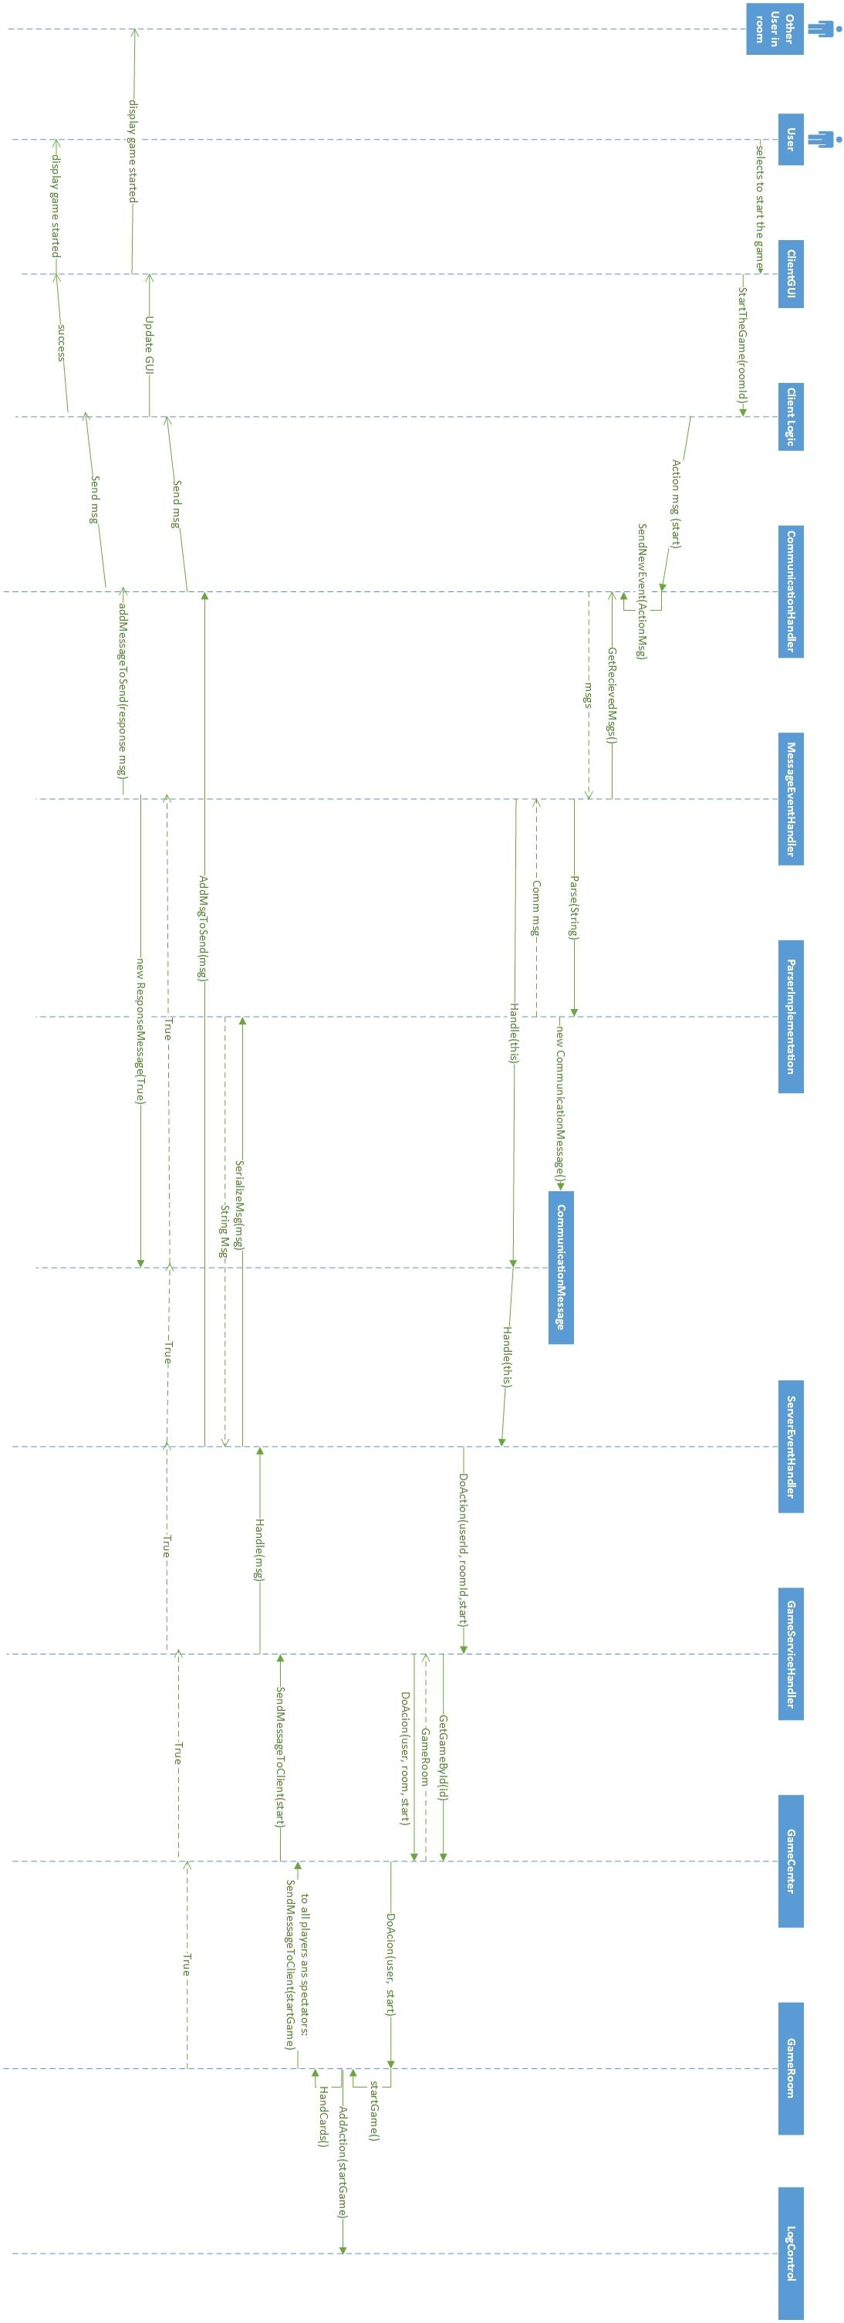

Leave Game:

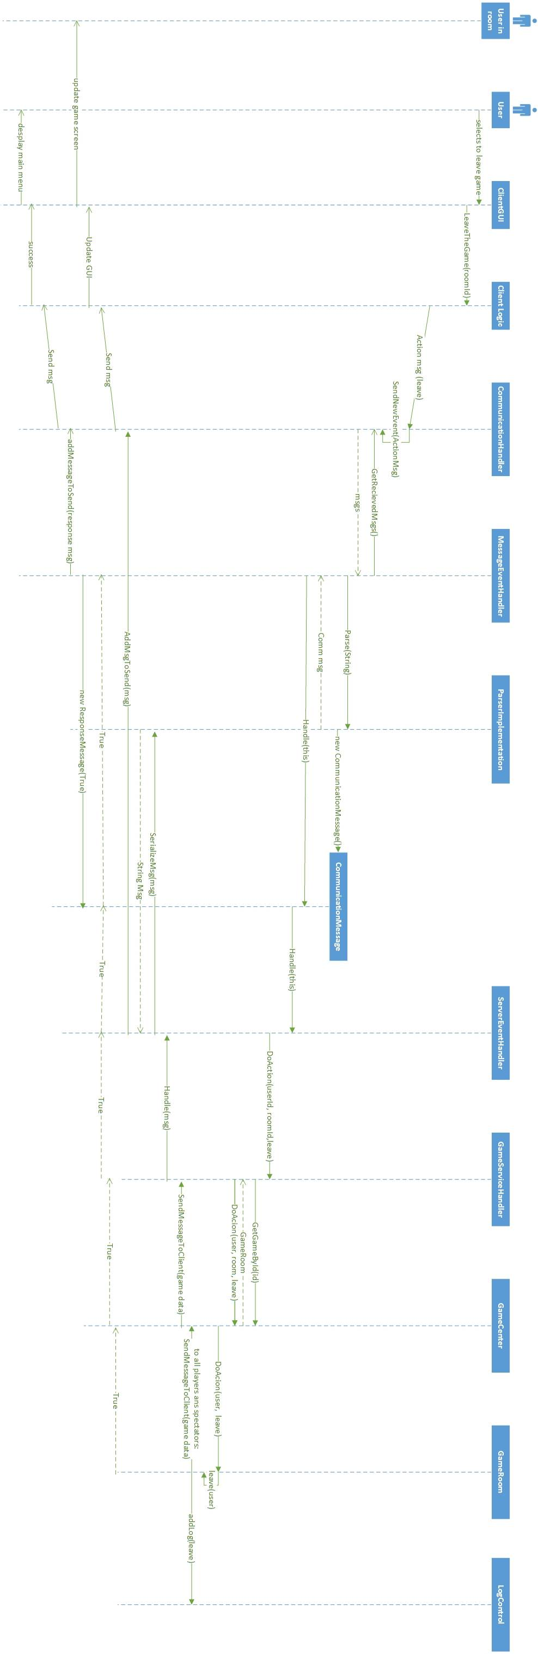

Fold:

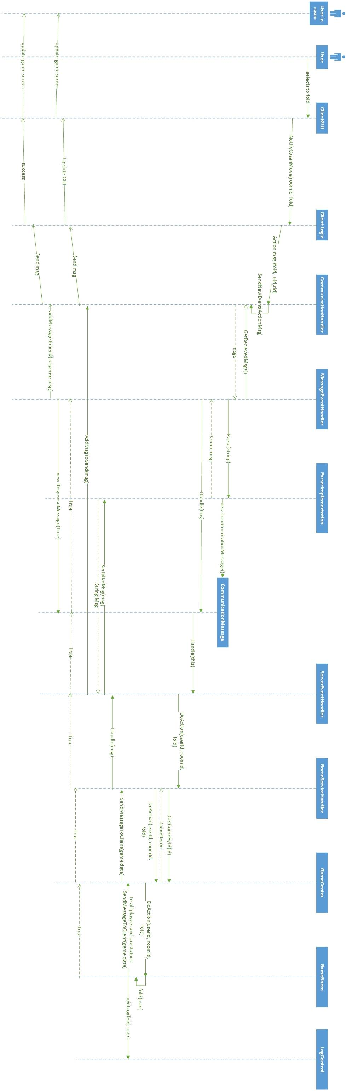

Check:

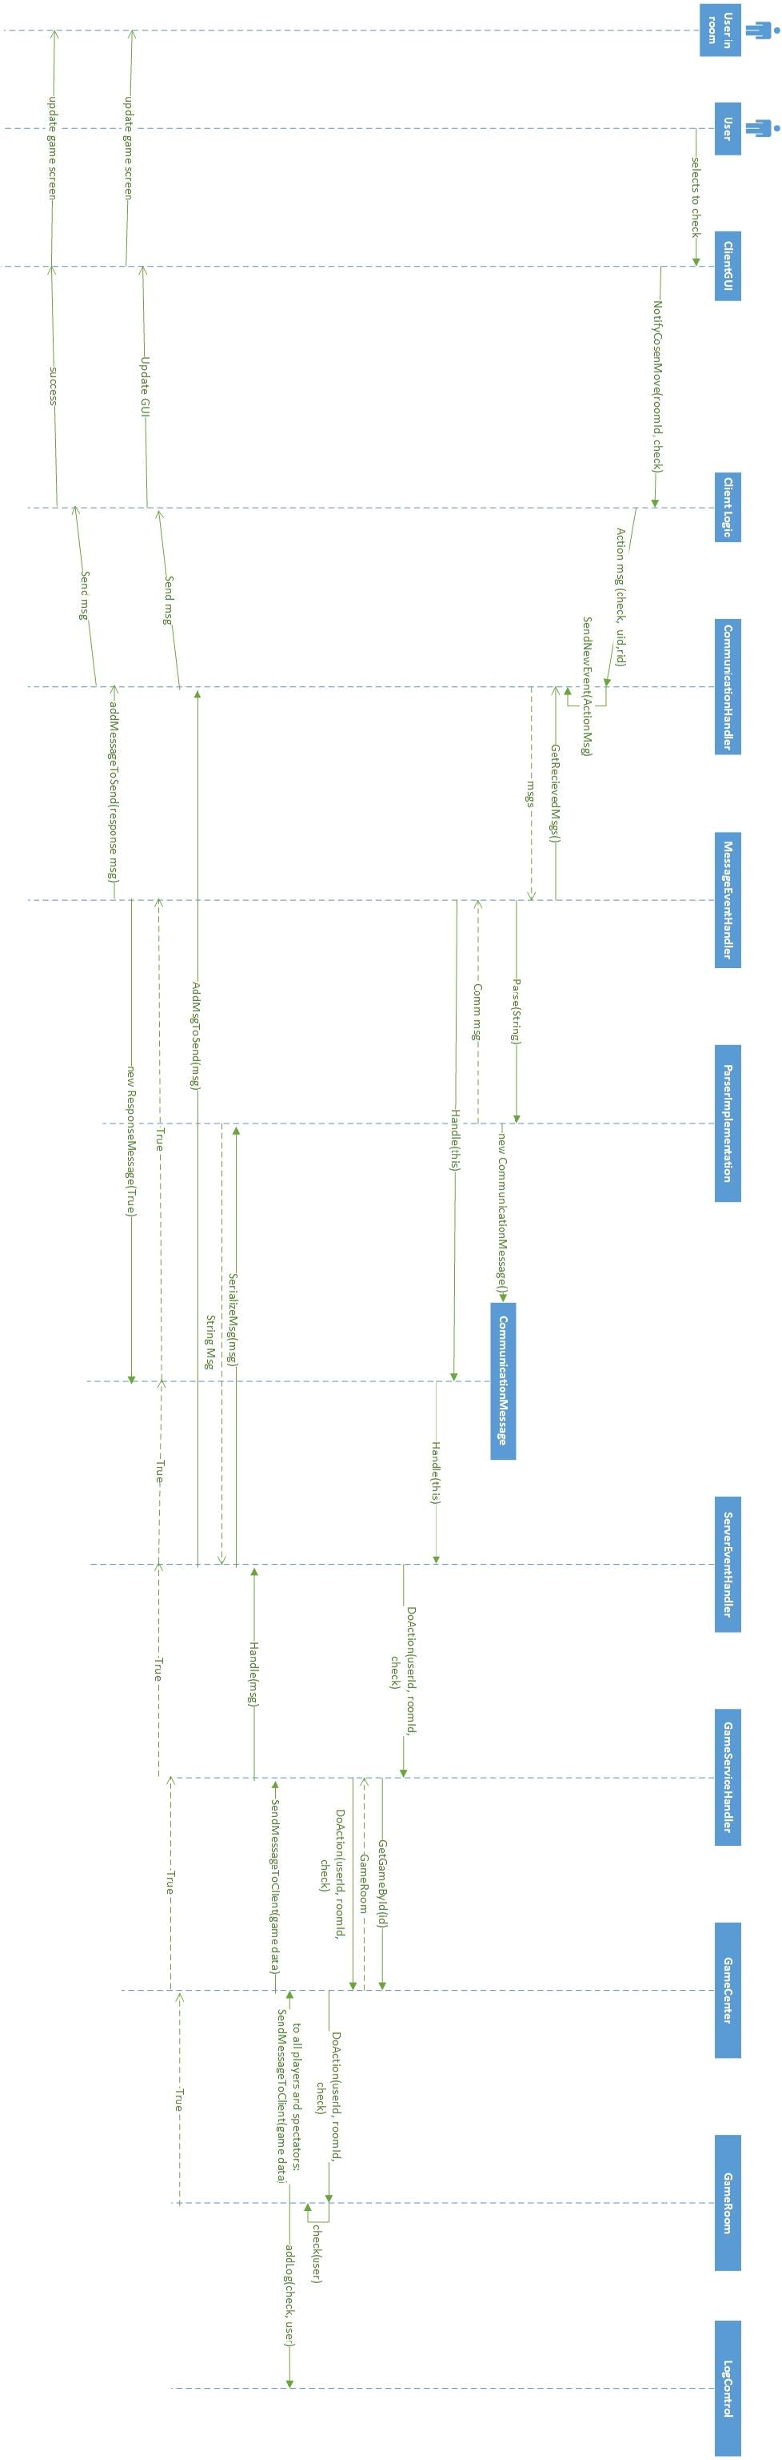

Bet:

